Title: COSTCO Internal Analysis Assignment

Name:
Course:
Professor:

Date:

Table of contents

Introduction 3
Management team 3
Board of directors 4
Value chain analysis of functional areas 7
Operations 7
Marketing 8
Finance 8
Human resource 8
Information technology 8
Research and development 8
Customer service 9
Identify key resources 9
Core capabilities (VRIO Analysis) 10
Value 10
Rarity 10
Imitability 11
Organization 11
Identify how the firm creates and sustains Unique Value 11
Membership 12
Design of products and services 12
Paying dividends to investors 12
Low prices for commodities 12
Great value 12
Store layout 12
Labor 13
SKUs 13
Scalable Operations 13
Commoditization 13
Solicit client feedback 13
Investing in research and development 14
Internal factor Evaluation matrix 14
References 16

Introduction
This paper will discuss the internal analysis of COSTO Company. The company has been in operation since 1976 which has given the company adequate experience that is needed in the retail industry to operate. Due to the changing markets, the company has gone through a lot in order to fight for its market segment and the competitive advantage over its rivals such as Wal-Mart. COSTO is a company that deals with customer service in the retail industry and provides a range of merchandise as well as shopping in order to guarantee customer satisfaction

Management team
The COSTO Company is managed by a very able team that is well experienced and forms different administrative positions. These positions include senior, middle level and junior management levels. The management team members are responsible in accomplishment of the set objectives in the company by the directors, creating of an ample working environment, operate the business as an honest and an integral institution that works in line of business ethics to satisfy its customers. The following are the members of the management teams that run the company towards the accomplishment of its objectives. They include;
W. Craig Jelinek, 64 who has worked in the company since February 2010. He is the Chief Executive officer in the company since January, 2012. He also forms part of the Board too.
John MCKay, 59 is the executive vice president as well as the Chief Operating Officer in the Northern Division of the company. He is the General Manager in the Northwest Region.
Paul Moulton, 65 is the Executive Vice President and the Chief Information Officer. He has worked in various positions in the company including the Real Estate Development.
James Murphy, 63 is the Chief Operating Officer who is responsible for running the operations of the company.
Timothy L. Rose, 64 heads the business, manufacturing centres as well as the merchandising operations of the COSTCO Company.
Joseph P. Portera, 64 forms part of the operational team in the company. He has had the opportunity to hold three positions in the company since 1994 when he joined.
Franz E. Lazarus, 69 is the Senior Vice President and an administrator in the global operations of COSTO Company.
Daniel Hines joined the company in 1999 and since then he has been the Corporate Controller as well as the principle Accounting Officer.
Ronald Michael Vachris, 51 is the chief Executive Vice president and the Chief Operating Officer he has held several other positions in the Company which include Real Estate development.
Dennis R. Zook, 67 is the Chief Operating Officer in the Southwest Division and Mexico.

Board of directors
Costco’s board of directors consists of an able team of 13 professionals who steer the company towards the right direction in accomplishing the strategies set by the company. The directors form a distinguished group of diverse professionals who have worked in various companies before joining COSTO Company and they have had the opportunity to gather a lot of experience that is golden wealth in the company. Some of these directors are the founders of the COSTCO Company and they have worked in various positions in the company since then.
Hamilton E. James
Chairman of the Board

Hamilton E. James is the chairman of the Board in COSTO. He has been a director in the company since 1988. He is also the President of the Blackstone Group. He is responsible in steering the affairs of the company which include global investments and the banking activities of the company. He has advanced experience in corporate management and investment banking which are very key to the company’s success. He is also experienced in trade of securities which has helped COSTO to succeed in running securities business.
Susan Decker
Director

Susan Decker is also a director in COSTO Company. He has been working for the company since October 2004. She came to the company with a lot of experience gathered from many companies that she has worked for including Yahoo Inc. where she was President from 2007-2009. She has over 20 years of experience in corporate management which is a big asset to COSTO. Her experience in research and development, publishing and advertising as well as economic analysis are some of the experiences that she brought to the company. Her nomination in the company as a director was recommended by a non-management director.
Kenneth D. Denman
Director

Ken Denman is also another very able director in COSTCO who forms part of the very able teams that runs the company. Before he joined the company. Kenneth Denman was the Chief Executive Officer in Emotient Inc. where he built a very artificial-Intelligence based platform which was useful in measuring facial expressions to predict emotions. Due to his able management the company was acquired by Apple in 2016. He has also worked in big companies such as Unwired Planet and iPass where he held high positions. His wealth of experience is useful in steering COSTO towards accomplishment of set goals.
Richard A. Galanti
Executive Vice President

Richard A. Galanti is the Executive Vice President and the Chief Financial Officer of COSTO since 1993. He has worked in COSTO, as the senior Vice President and the Chief Financial Officer since 1993. In 1984 he worked as Executive Vice President. He also have extensive experience in securities where he worked as an Associate with Jenrette and Donaldson Lufkin Securities Corporation.

W. Craig Jelinek
President, CEO and Director

Craig Jelinek became the position of President, the Cief Operating Officer and the Director in 2010. In COSTO, he has held several positions where he has been very successful. He has held positions in senir management levels such as Operations and Merchandising since 2004. Before he joined COSTO, Craig Jelinek was working in various management positions in different companies which among them include Gemco and Fed-Mart.

Daniel J. Evans
Director

Daniel J. Evans has been the director of COSTO since 2003. Throughout his corporate career, Daniel Evans has been responsible to some of the world’s biggest companies. He has also served the government of U.S in 1983-1989 as a Senator. He has also served the Evergreen State College from 1977-1983. He has also served as a governor in the state of Washington among other companies which include Western Wireless Nic Inc as well as Archimedes Technology Group. He serves the COSTO Company whole-heartedly which has succeeded from his extensive career experience.

John W. Meisenbach
Director

John Meisenbach is one of the longest serving directors in COSTO Company. He has been working in the company since its inception as a director. In the company, he serves various positions among them President of MCM and Financial Services. He gathers a lot of experiences that are useful to the COSTO Company in the various positions that he hold in other organizations such as M Financial Holdings and Expeditors International. He is also a trustee in Elite Fund.

Richard M. Libenson
Director Emeritus

Richard M. Libenson has been the director of the companysince 1993. Before joining the company, he previously worked in management positions in various companies such as Price Company (1976-1989). He then retired from being an active office in the company whereby he would later join COSTO Company. He has a wealth of experience that he has brought in the company.

Charles T. Munger
Director
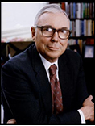
Charles Munger has worked in COSTO Company as a director since 1997. He also serves as the Board of Directors In the Daily Corporation, Chairman of Board of Berkshire Hathaway Inc and also as the Chairman of Directors-Wesco Financial Corporation.
Jeff Raikes
Director

Jeff Raikes has served the company as a director since 2008. He is one of the founders of the Raikes Foundation. He has also worked in the Bill and Melinda Gates Foundation (1981-2008) where he also worked in the Business division. He has gathered a lot of experience that is useful in running the affairs of COSTO.
John W. Stanton
Director
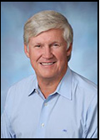
John W. Stanton forms the team of able directors who run the COSTO Company. He has a collection of experiences that he has acquired from serving a number of companies which include Trilogy Equity where he served as the Chairman. He is the Chief Executive Officer of the Western Wireless Corporation where he served from 1992 until it was acquired by ALLTEL Corporation in 2005. He also served as the chairman and the director of T-Mobile USA, Voice Stream Wireless Corporation. He also worked as a director of Clear wire Corporation among many other companies. He is currently a director in the Microsoft and Columbia Sportswear.
Maggie Wilderotter
Director

She serves as one of the directors of COSTCO Company. She has served in a number of executive roles which include the fields of technology and telecommunications. The companies where she has served include Microsoft, McCaw Cellular, Wink Communications and AT&T Company. In the companies where she has served she has gained sufficient experience that is needed by COSTO Company in running its affairs.
James D. Sinegal
Co-Founder and Director

James D. Sinegal was the Chief Executive of COSTO until he retired in December, 2011. Until February 2011, He served as the president of the company and later on as a non-officer employee through April 2013. He has worked as a director since the company’s inception and he belongs to the team that founded the company. He serves in the Board as a co-founder of the company, Chief Executive Officer, President in his extensive career in the retail business where his advanced experience has been of great importance to the company.

Value chain analysis of functional areas

Operations
COSTCO Company operations manages over 700 warehouses across the globe in a responsible and energy efficient way. These are efforts by the management of the company to maximum utilise the valuable resources, remain a low-cost operator and reduce on carbon emissions which are a threat to the environment. The operations of the company also work to save on money and energy costs.

Marketing
COSTCO Company has engaged in extensive advertising and sale campaigns through multiple channels such as the use of direct mails. The company has embarked on a marketing campaign that features new customers as well as the new warehouse openings in various geographical locations. Various members of the different membership are contacted by the customer care service of the company whereby they are informed of new deals offered in the company’s stores that could be of great benefit to them. Direct mail is commonly used by the company because it is cheap and it reaches the customer on the ground easily. It is very easy therefore to get information quickly on the offers in the stores and quickly make the initiatives of buying the same before it runs out of stock.

Finance
The company over the years has creates a good and friendly environment that has attracted financial institutions to the company. This ensures that the company can get financial gains from them when it needs them. The company too has strong financial muscles due to the high revenues its gains through its high sales. The company has a rapid inventory turnover which gives it the opportunity to pay merchandise vendors which helps the company to take the advantage of early payment discounts. The company is able to finance its merchandise inventory through the terms of payments provided by the vendors instead of working to maintain a sizable working capital. Its financial also enables it to make timely compensations for its employees which helps the company to gain a high competitive advantage.

Human resource
The HR department in the company has worked tirelessly to ensure that its employees are constantly trained on customer service in a bid to ensure that the sales of the company are high. On the other hand, employees are treated with executive compensation schemes that encourage them to work harder to raise the sales in the company. The reward system also recognizes the best performing employees who are offered a number of rewards such as bonuses, free shopping sprees, tickets and good salaries with good promotions.

Information technology
The changing world of technology requires a company to be very keen in order to update to the current technology. When a company fails to do so it might find itself in an obsolete environment and it may threaten its existence in the market. COSTCO Company has stayed for long in the market despite the many rivals who join the market every day. In order to remain competitive in the market COSTCO has maintained modern and new technology in all its operations towards customer service. Its payments uses state of the art system that is very fast and accurate, customers are able to communicate to the company customer service through social platforms easily among other features. When it comes to marketing and advertising, the company has remained digital as well as designing its product image.

Research and development
Research and development is very key in the company. The company is able to seize opportunities and innovate them to reap revenues. The customer needs keep on changing and the company needs constant research in order to realize the customer wants and needs and act upon them. The company is also able to discover the market gaps in the market and provide services and products that will satisfy the customer. The customer wants unlimited access to the most quality resources, tools as well as solutions.

Customer service
COSTCO Company has maintained top quality service for its customers who enjoys its products and services. The company works round the clock through its able staff to provide the customer with the needed service which ensures that purchasing is efficient. In order to increase its customer satisfaction, the company has worked on several strategies which include pricing, product selection and meeting the market gaps. Its pricing strategy is one of the best in the market because it covers all the financial levels of its customers. Customers are able to get what exactly they want in the warehouses with each having over 150,000 different items to shop.

Identify key resources
Network of physical warehouses
COSTCO Company has a good network of physical warehouses. The warehouses has a good network that ensures there is a good communication and clients/customers can be served from any point. On the other hand, the management finds it easy to pass information and concerns from one point to other easily without any inconveniences. Customers are well conversant with the routes where they can find each warehouse which have been placed in strategic placed that are easy to access.
IT infrastructure
COSTCO Company uses the latest technology in running its affairs whether it is communication, design, purchase, sales, payment of workers and so forth. This ensures that the process of doing business with the relevant stakeholders e.g. suppliers is easy and efficient. It is also very cheap to use the latest IT infrastructure which makes the store very competitive in the market. On the other hand, customers will appreciate IT because they know the services are fast and accurate.
Supply chain
The company’s supply chain is very efficient. This is to ensure that stocking is up to date and that customers will never ever at any moment lack something from the shelves simply because it has run out. The company has reliable chain of supplies that meets the customer’s demand right on time without delay in order to ensure customer satisfaction is upheld.
Logistics and distribution networks
The company’s logistics and distribution networks are up to standard. Goods are well supplied from the main stores to the retail shops right on time. When customers require bulk delivery of items the company logistics system is ready and standby to deliver. This makes the customers love to trade with the stores because of the good distribution networks it has.
Personnel
COSTCO Company has a very able team that ensures that the activities and operations of the company are running smoothly all the time whether there is a boom or recession in the market. The leaders are qualified for the job. The workers are hardworking and motivated to perform.

Core capabilities (VRIO Analysis)
It is important for COSTO to realize if it is in a position to maintain its competitive advantage. This gives the company a view of its ability to compete with its rivals. This section requires analysis of the company’s capabilities using a structured resource-based approach called VRIO. VRIO stand for value, rareness, imitability and organization. Several answers are attended to by the structure such as whether the resources owned by the company are valuable. When the resources of COSTO Company are valuable it means that COSTCO Company can increase its market share and be able to achieve cost advantages or both. However, the value of the company’s resources is not a source of competitive advantage. When the resources of COSTO Company are valuable but rare and the competitors have the same resources, then organization has nothing to control its advantage in the resources. In order drive its sales COSTCO relies on the application of VRIO on the customer base.

Value
In order to arrange a good deal the customer in terms of price of goods, COSTO Company offers value for bulk pricing. This ensures that there is a leverage with the suppliers who are the key players for organizing the best deals for the customers. Positive brand correlation in the company has been noticed across multiple consumer channels. This is an opportunity taken by COSTO Company to add value to its resources with an aim of creating a perceived value for the customer. Customers will always forego the commodity that is perceived to be more valuable no matter the price. Of course when COSTO Company has a high perceived value for its commodities compared to other rivals such as Walmart Company, many customers will tend to accept commodities for COSTO Company. In order to make this opportunity work, COSTCO Company has ensured that all its products are well differentiate in order to make sure that they lead in the market share. Differentiation has been achieved through redesigning of its products and creating fair prices for its commodities. In order to maintain the value for its commodities, COSTO Company continuously reviews the value of its resources because of the ever changing external and the internal conditions which could threaten the value for the resources.

Rarity
When resources are acquired by one or two companies, they are regarded as rare. When resources are rare, the company that possess such commodities may be in a position to enjoy competitive advantage. When many companies possess the commodity it ceases to become rare and may lead to competitive parity. This is because the companies which possess the resources have a likelihood of implementing almost the same strategies and it becomes difficult for any of the companies to achieve a superior performance. However, a company might not be forced to neglect resources just because they are common though valuable. Losing such resource due to their commonness in the market may be hurting to the company. To some extent, these resources are important in the market.
COSTCO Company has a restricted level of access to commodities in the market which ensures that resources which are valuable in the market are acquired before somebody else. This is a good opportunity to create an illusion that the product stocked is of high demand and will not last forever. What will happen is that customers will strive the commodity and only the Elite in this case may be in a position to get these products.

Imitability
In COSTCO Company, price efficiencies may be copied in many channels and market stores such as Walmart in order to associate themselves with the positive image of competitiveness that COSTCO Company associates itself with. The company creates an exclusivity of its products in the market that ensures no matter the imitability in the market, COSTO Company is able to maintain a smooth revenue curve.
Imitation of COSTO Company products can take place in two ways: by providing a comparable substitute and direct imitation which is referred as duplicating. However, COSTCO Company has maintained a positive image in the market for many years and rivals always find it hard to imitate due to; history of the company, social complexity and the causal ambiguity.

Organization
In order to capture value to its customers, COSTCO Company has organized its policies, management systems, culture, organizational structure in a manner that will ensure the its resources are valuable, costly to imitate and rare. This is intended to create a sustained competitive advantage for the company. It is a source of sustained competitive advantage in the company. However in order to capture a great customer view of the company’s value to its customers, it calls for a few strategies that COSTO has worked towards achieving. They include;
- Managing its customers effectively to create a good source of cost advantage and differentiation
- Using data of its customers to manage them
- Process and capacity design to optimise cost effectiveness.
- Hiring the best skills that will promote the company’s image. That is why COSTCO has hired the best personnel which has gathered adequate experience in various fields.
- Including a motivation and reward system in the company for both the customers and the employees.
- Maintenance of COSTCO Company facilities through training and development programs.
- Creating a culture of rewarding innovative ideas
- Design of goods and services which includes photo centre services, optical services
- Quality management of resources and establishing a consistency
- Layout design and strategy to minimise the use of extra space.

Identify how the firm creates and sustains Unique Value
COSTCO Company is effectively leveraging the operations and activities of the company in order to sustain and drive growth as well as business advantage. The company has over 600 warehouses and over 80 million cardholders. The company has built its business model in the following current and potential key areas in order to maintain a competitive advantage;

Membership
In order to shop at COSTCO Company, it is a must you pay for membership or visit the store with a registered member. There are three membership levels that are offered by the company. They include Gold Star which costs $55 per year, business card which cost the same as the gold star and the executive which is $110 per year. Any member is granted the access to all warehouse locations and is eligible to rewards as well as services according to their membership cards.
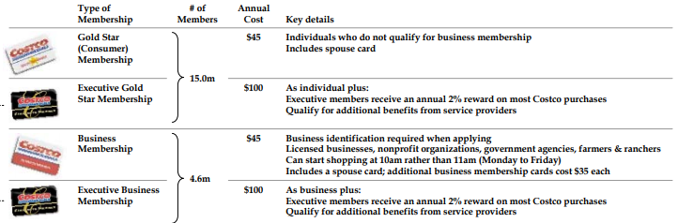

Design of products and services
COSTCO Company is the first retail store recently to offer its customer unique services such as photo centre services, insurance services and optical services which was not the case before some time back. It has become a one-stop shop for customers who have limited time.

Paying dividends to investors
COSTCO has started paying its shareholders dividend recently. This is an initiative calibrated by the company to paint a positive image of the company in the market as a potential player in the market. This is a move by the company to create a friendly market for investing

Low prices for commodities
The company offers its customers products at a competitive price. In order to leverage its efficiencies of scale the company has over the years strived to be the best store that offers its customers the best prices as compared to the rivals. This has enabled its customers to save and that what any customer would like to have.

Great value
COSTCO Company creates quantity and quality perspective. The company leverages bulk quantities in order to drive cost per unit which results to a greater value for the customer. When the quality of products is high, customers seek for the satisfaction guaranteed by the company. This is because the customers gain confidence because of the great value created by the company.

Store layout
COSTCO Company has one of the best layouts for its stores. They are no frills. The interior and exterior design have been modelled to create a difference from any other store in the industry. The stores have cement floors, pallets of goods and metal shaves which is a differentiation feature from the typical stores. The warehouses are able to accommodate large number of customers at the same time who can move quickly through the shelve lines with their carts in a comfortable way. The company has also set out display showrooms in its stores as shown below.
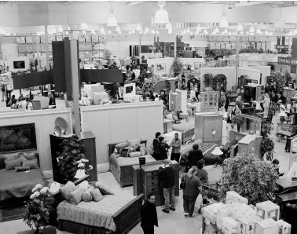


Labor
The company has not been mean in employing skilful employees whom they train on development occasionally. There are reachable employees within the stores who offer assistance to shoppers at all times in any of the company’s premises. This ensures that there is no commotion in the stores and customers are not lost in what they want. This makes the purchasing process in the store to be very efficient. Efficient is something that the company has invested on in its labor model. This is what encourages many customers to visit the stores and buy from them.

SKUs
The company offers its customers 3700 SKUs. This ensures that the company lays its focus on the sale of items that are on high demand by the customers in the market.

Scalable Operations
Through its warehouses, the company uses its experience, financial strength and the size to grow its market share. It is able to grow in its supplier relationship, product development and design among other factors.

Commoditization
In order to address the fear of rubber-stamping the company’s business ideas, COSTO Company has re-established the customers value that keeps the company constantly engaged in order to maintain high customer satisfaction and reduce any chances of substitution. In case of any customer complaints, COSTCO has placed an able team of employees who work on the complaint immediately it is raised.

Solicit client feedback
Customers who visit the stores are highly encouraged to provide the company with their view of the value received. This gives COSTCO Company a chance to review its services and products it provides to the customers. It also helps the company to uncover revenue opportunities using its existing client base. Through this solicitation process of feedback, the company is able to discover the client feedback. The feedback can be delivered manually at the premised in the feedback drop box or online.

Investing in research and development
COSTCO Company knows very well that every day there are new rivals getting in the market with crazy offers. The company has an able team that conducts extensive research in the market system to uncover the strategies that have been set by rivals which could be a threat to the company’s competitive advantage. Through research and development, the company is able to discover opportunities in the market as well as unexploited markets that are valuable to the company. Through research and development the company is able to realise options in the market that it needs to adopt in order to grow. The diagram below shows some of the market growth options the company has researched on and is currently working on.
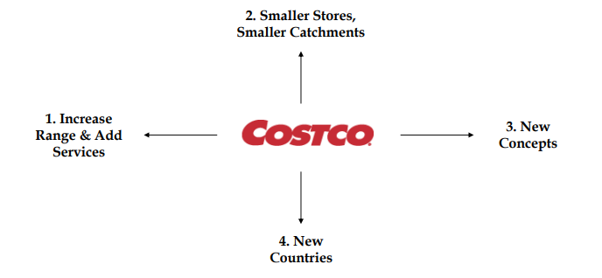

Internal factor Evaluation (IFE) matrix
This IFE aims at conducting an internal audit of the COSTCO Company. The matrix used different functional areas of the company such as marketing, finance, accounts, Human Resource, management, customer loyalty, market share, value added services and product quality among other factors to determine the competitiveness of the company. The target in this market is to ensure COSTCO Company capitalizes on its strengths as a firm and fortify them with the existing economic conditions in the market. The internal analysis gives the company a view of its competitive advantage using the following components namely; strengths and weaknesses to realize its market competitiveness.
From the figure below it is evident that COSTCO Company has high value assets, a strong financial condition, best product quality and a strong marketing promotion. On the weakness part of the company there is a loss in joint venture. Weakness in management whereby there is a lot that needs to done by the company’s management in order to fight the daily growing competition from new entrants. Minor weaknesses include merchandise options that the company needs to look at. It is important also for the company to observe the customer loyalty and maintain it. There are many ways to do so and it could not be the best way as time goes by to force any customer to register in order to purchase in the warehouse. Loyalty cards can also work for the company.
The areas where the COSTCO Company is slightly strong at product quality and price competitiveness among other factors.

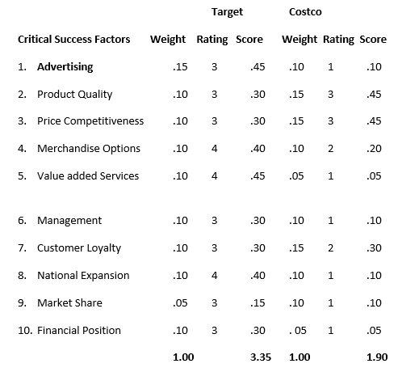

References
Barney, J. B., & Hesterley, W. S. (2015). Strategic management and competitive advantage: Concepts.
Brown, I. T. J. (January 01, 2017). Cultivating Recognition.
Costco. (2012). Place of publication not identified: Book on Demand.
Daft, R. L., & Marcic, D. (2016). Understanding management. Princeton, N.J: Recording for the Blind & Dyslexic.
Daft, R. L., & Daft, R. L. (2017). New era of management. Mason, Ohio: Thomson South-Western.
Grant, R. M. (2012). Contemporary strategy analysis: Concepts, techniques, applications. Malden, Mass. [u.a.: Blackwell Publ.
Harrison, J. S., Bosse, D. A., & Phillips, R. A. (January 01, 2010). Managing for stakeholders, stakeholder utility functions, and competitive advantage. Strategic Management Journal, 31, 1, 58-74.
Knapp, D. E. (2008). The Brandpromise: How Costco, Ketel One, Make-a-wish, Tourism Vancouver, and other leading brands make and keep the promise that guarantees success!. New York: McGraw-Hill.
Richardson, J. E. (1996). Marketing 96/97. Guilford, Conn: Dushkin.
Stallard, M. L., Pankau, J., & Stallard, K. P. (2015). Connection culture.

